Comparison to other technologies:

Novel technologies :

The Fuel cell , Thermo electrics and Batteries are the most popular energy suppliers .

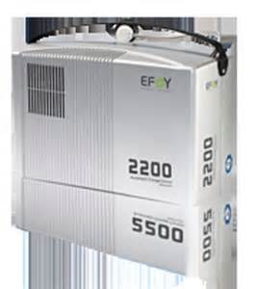 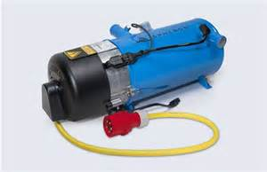

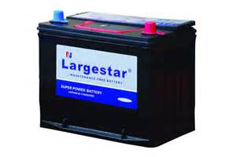

The rate of power suppliers in different regions

Main areas of competition :

Different technologies mainly compete with each other on:

* usage
* cost
* safety aspect
* standards and regulations

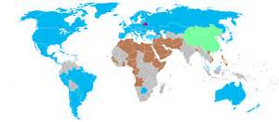

Another dimension of competition:



The policy :

Different policies in different nations play an important rule on this area

Advantages and disadvantages of hydrogen fuel cell :

